Anna Zofia Gąsienica Byrcyn
POLISH REFERENCE BOOKS,
TEXTBOOKS & DICTIONARIES

VERBS

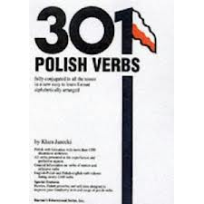
301 Polish Verbs written by Klara Janecki & published by Barron’s Educational Series, Inc., offers:
- conjugation patterns of verbs in the present, future, past tenses
- verbs presented in the imperfective & perfective aspects
- determinate & indeterminate verbs of motion
- reflexive verbs
- conditional & imperative moods
- participles
- English-Polish and Polish-English verb indexes listing 2,300 verbs
- all the explanations & grammatical terminology are given only in English

- 301 Polish Verbs is a very good reference book for Elementary, Intermediate, and Advance Polish language classes.

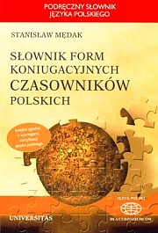

Słownik form koniugacyjnych czasowników polskich written by Stanisław Mędak & published by Universitas includes:
- conjugation patterns of verbs in the present, future, past tenses
- verbs presented in the imperfective & perfective aspects
- determinate & indeterminate verbs of motion
- reflexive verbs
- conditional & imperative moods
- participles
- verbal nouns
- 6,000 Polish verbs are NOT translated into the English
- all the explanations & grammatical terminology are given in English & Polish

- Słownik form koniugacyjnych czasowników polskich is an excellent reference book for Advanced Learners of Polish language, Heritage speakers & Native speakers.

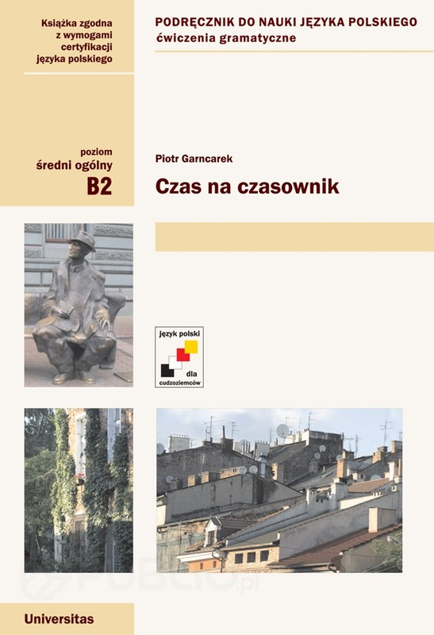

Czas na czasownik written by Piotr Garncarek, published by Universitas, is composed of 35 units with entertaining, humorous texts & exercises connected to the readings devoted to:

present, past, & future tenses
aspect (imperfective & perfective verbs)
conditional & imperative moods
passive voice
determinate & indeterminate verbs of motions
impersonal forms of verbs
participles
verbal nouns

- The textbook Czas na czasownik is recommended for Intermediate, Advanced Learners, and Polish Heritage Speakers.
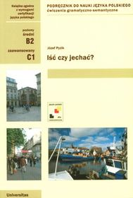

Iść czy jechać? Written by Józef Pyzik is a textbook on determinate & indeterminate verbs of motion.

The book contains explanations & exercises on the verbs of motion + prepositions + nouns in appropriate cases.
The textbook has charts of verbs + prepositions + cases.
There are conjugations of determinate & indeterminate verbs of motions in all the tenses.

- This textbook is recommended for Intermediate & Advanced levels.

NOUNS

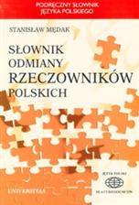

Słownik odmiany rzeczowników polskich written by Stanisław Mędak & published by Universitas offers:

- declension paradigms of 20, 000 nouns:
- feminine nouns
- masculine virile nouns
- masculine animate nouns
- masculine inanimate nouns
- neuter nouns
- nouns without singular forms
- all the explanations & grammatical terminology are given in English & Polish
- Polish nouns are NOT translated into the English

- Słownik odmiany rzeczowników polskich recommended for Advanced Students, Heritage & Native Speakers.

IDIOMS

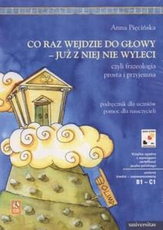

Co raz wejdzie do głowy – już z niej nie wyleci, czyli frazeologia prosta i przyjemna +CD written by Anna Pięcińska & published by Universitas gives:

1. idiomatic expressions linked to body parts, colors, plants, animals, directions, numbers
2. exercises on the given idioms
3. games
4. idioms are NOT translated into the English
5. readings with idioms

- Recommended for Polish Composition & Conversation classes & Heritage Speakers.

SPELLING

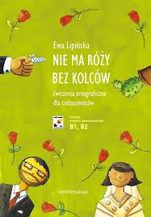

Nie ma róży bez kolców written by Ewa Lipińska & published by Universitas includes rules & exercises on:

- the use of upper & lower case letters
- voiced & unvoiced consonants
- soft & hard consonants
- spelling of ji, ii, i; ą, on, om ę, en, em; ó, u; rz, ż; ch, h
- the use of punctuation marks
- when to write nie together or separately

All the spelling rules are given in Polish.

- Recommended for Polish Composition & Conversation classes and Polish Heritage & Native Speakers.

GRAMMAR & COMMUNICATION

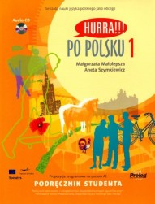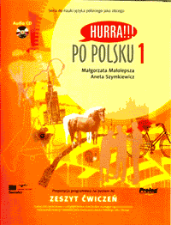

Hurra po polsku 1. Podręcznik Studenta & Hurra po polsku 1. Zeszyt ćwiczeń + CD written by Małgorzata Małolepsza & Aneta Szymkiewicz, published by Prolog.
The textbook is composed of 0 – 20 communicative lessons with grammar for practicing speaking, listening, reading, and writing skills.
Grammar: alphabet, grammatical terminology, personal pronouns, gender of nouns, adjectives, & demonstrative pronouns, adverbs, adjectives of nationality, nouns of nationality, descriptive adjectives, nominative singular of nouns, adjectives, and pronouns, instrumental singular and plural of nouns adjectives, and pronouns, accusative singular of nouns, adjectives, and pronouns, nominative & accusative plural of non-viril nouns & their modifiers, genitive singular & plural of nouns, adjectives, and pronouns, locative singular & plural of nouns and adjectives, present, future, and past tenses, indeterminate & determinate verbs of motion, aspect of imperfective & perfective verbs.
Communication: Greeting & farewell expressions, Introduction of oneself & others, description of objects & people, expressing liking & disliking, every day activities, telling time, asking for information & road directions, shopping for groceries & clothing, giving complements, making plans for a weekend/vacation/future, description of a city, talking about vacation, description of a house/apartment, health issues, biography, sport, studies, traditions & holidays, office as a work place.

- Recommended for Beginning Polish
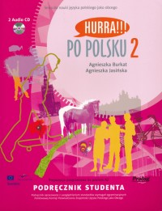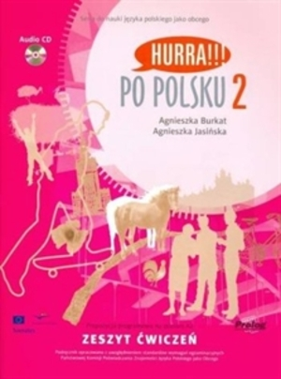

Hurra po polsku 2. Podręcznik Studenta & Hurra po polsku 2. Zeszyt ćwiczeń + CD written by Agnieszka Burkat & Agnieszka Jasińska, published by Prolog.

The textbook is composed of 20 communicative lessons with grammar for practicing speaking, listening, reading, and writing skills.
Grammar: nominative plural of viril nouns and their modifiers, aspect of imperfective & perfective verbs, adverbs, conditional mood, impersonal forms of verbs, locative case, dative case, verbal nouns, adjectival participles, passive voice, direct & indirect speech.
Topics: description of personality, job, life of a man, education, life in a city, life in the countryside, family, friends, home & household appliances, discoveries, healthy style of life, tourism & travel, holidays, Internet, literature & press, cinema.

- Recommended for Indermediate Level.

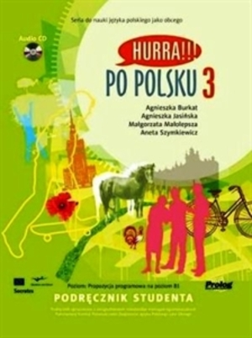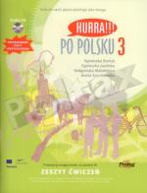

Hurra po polsku 3. Podręcznik Studenta & Hurra po polsku 3. Zeszyt ćwiczeń + CD written by Aneta Szymkiewicz, Małgorzata Małolepsza, Agnieszka Burkat, & Agnieszka Jasińska, published by Prolog.

- Recommended for the Third Year Polish.

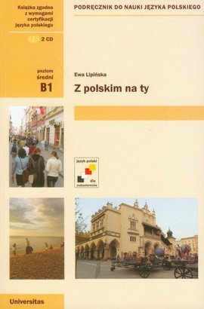
Z polskim na ty + CD written by Ewa Lipińska & published by Universitas is divided into 2 parts:

Part I gives rules & exercises on:
7 cases of nouns, adjectives, & pronouns
comparative & superlative of adjectives
present, past, & future tenses
comparative & superlative of adjectives & adverbs
impersonal forms of verbs
imperfective & perfective aspect
reflexive verbs
imperative & conditional mood

Part II offers topics with readings & exercises on:
interests & hobbies
family & friends
personality
iIlness
weather
seasons
months
holiday cards
formal & informal letters, cards & notes

- Recommended for Polish Heritage Speakers.
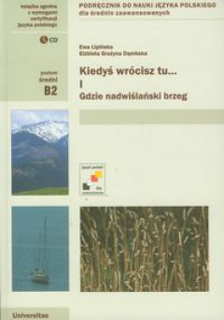

Kiedyś wrócisz tu… Gdzie nadwiślański brzeg, cz. 1 + CD written by Ewa Lipińska.

The textbook is composed of 8 lessons. Each lesson has 3 parts:
- Communication: excerpts from newspaper articles, communicative phrases, topics for discussions
- Reading: texts & poems, new vocabulary and idioms, topics for compositions
- Grammar: nominative plural of virile nouns, adverbs of languages, compound adjectives and numerals, direct & indirect speech, object clauses, attributive clauses, adverbial clauses of manner, degree & measure, adverbial clauses of time & place, subordinate relative clauses

Communication: Telephoning, Discussion, Interview, Request, Advertising, Persuasion, Discussion (revision), Compromise
Topics: Internet, Warsaw, Poles, Driving, Music, Vacation, Health, Work, Crime, Animals

- Recommended for Polish Composition & Conversation & Heritage Speakers classes.

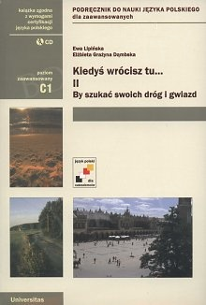

Kiedyś wrócisz tu... By szukać swoich dróg i gwiazd, cz. II + CD by Ewa Lipińska.
This textbook is a second volume of the book Kiedyś wrócisz tu... Gdzie nadwiślański brzeg.

The book is composed of 8 lessons. Each lesson has 3 parts:
- Communication: excerpts from press articles, communicative phrases & expressions, topics for discussions
- Reading: texts & poems, new vocabulary and idioms, topics for compositions
- Grammar: impersonal forms, double & multiple negations, imperative mood, aspect of verbs, active adjectival participles, conditional mood, passive adjectival participle, passive voice, declension of cardinal numerals, compound words, collective numeral, non-personal forms, feminine nouns

Communication: Expressing Opinion, Indignation & Protest, Compliment, Requesting Advice, Argumentation, Fear, Indifference & Fascination, Comparisons, Expressing Opinions & Argumentation (revision)
Topics: Studies in Poland, Children & Ageing, Fashion, Food & Travels, Kraków, Legends, Addiction, Cell phone, Zakopane & the Tatras

- Recommended for Advanced Composition & Conversation classes & Heritage Speakers.

GRAMMAR

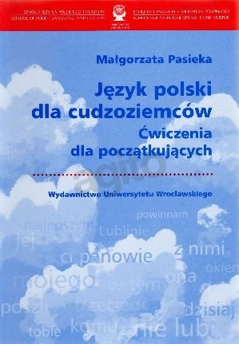

Język polski dla cudzoziemców. Ćwiczenia dla początkujących written by Małgorzata Pasieka & published by Wydawnictwo Uniwersytetu Wrocławskiego is a collection of grammar exercises covering:

nominative, accusative, genitive, dative, instrumental, locative of nouns, adjectives, & pronouns
comparative & superlative degree of adjectives & adverbs
personal, possessive, relative, & interrogative pronouns
numerals
present, past & future tenses
imperative & conditional mood
prepositions
conjunctions

All the instructions for the exercises are written in Polish & English.

- This collection of exercises is recommended for Polish Heritage Speakers.

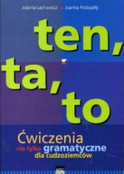

Ten, ta, to. Ćwiczenia nie tylko gramatyczne dla cudzoziemców written by Jolanta Lechowicz & Joanna Podsiadły, published by Wydawnictwo WING.

The book is a collection of communicative exercises covering:

- useful, practical topics
- grammar
- spelling
- writing of short texts, brief notes
- reading & comprehension

- Recommended for Beginning Level as an additional source of various exercises.

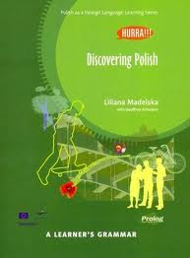

Discovering Polish by Liliana Madelska & Geoffery Schwartz, published by Prolog.

A guide on grammatical terminology with paradigms:

- verbs
- nouns
- adjectives
- pronouns
- numerals
- adverbs
- conjunctions
- participles

- Recommended for Intermediate Polish

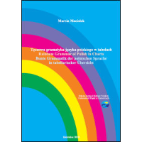

Tęczowa gramatyka języka polskiego w tabelach. Rainbow Grammar of Polish in Charts by Marcin Maciołek, published by Szkoła Języka i Kultury Polskiej Uniwersytet Śląski w Katowicach
consists of basic charts on:

- noun declensions
- adjective declensions
- colors
- geometric figures
- cardinal numerals
- ordinal numerals
- collective numerals
- time

- Recommended for Elementary Polish & as a review for Intermediate Polish

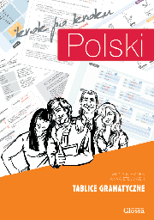

Polski, krok po kroku. Tablice gramatyczne by Iwona Stempek & Anna Stelmach, published by Glosssa.

Polski, krok po kroku. Tablice gramatyczne is a set of large 34 charts of key grammar topics from the Polish language presented in a very clear way. The charts facilitate acquiring all the topics of grammar such as: cases, conjugations, tenses, aspects, verbs of motion, static and dynamic prepositions, numerals, comparative/superlative forms of adjectives and adverbs.

All the grammar explanations are given in Polish.

- Recommended for Beginning & Intermediate Learners of Polish language.

WRITING TEXTS

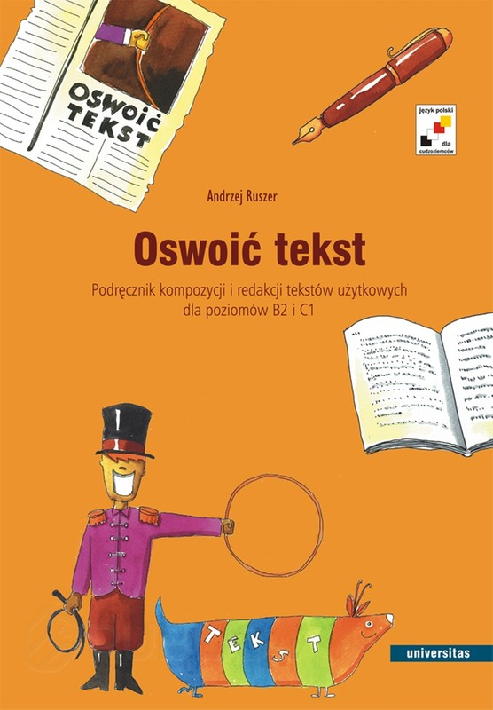

Oswoić tekst. Podręcznik kompozycji i redakcji testów użytkowych by Andrzej Ruszer shows how to write:
- Thank you notes
- Invitations
- Complaints
- Ads
- Arguments
- Film reviews
- Book reviews
- Biographical notes
- Description of an object
- Description of a painting

- Recommended for Polish Composition & Conversation classes.

READING & WRITING

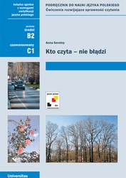

The book Kto czyta nie błądzi by Anna Seretny has 8 units composed of several reading texts on such topics as: cultural differences, language, education, interests, health, nature, travels, 20th century. The readings are complemented with a set of exercises aimed to develop and master discussion, argumentations, and writing.

- The book is recommended for the Polish Composition & Conversation classes.

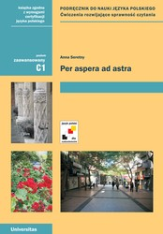

The book Per aspera ad astra by Anna Seretny has 8 units on such topics as: family, work, health, food, addictions, crime, media, advertisements. Each unit offers several reading texts with exercises aimed at mastering idiomatic expressions, synonyms, antonyms, and the art of writing brief compositions.

- This book is recommended for the Polish Composition & Conversation classes.

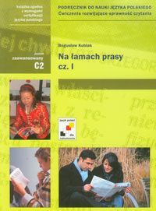

Na łamach prasy, cz.1 written by Bogusław Kubiak

The book offers 13 units on various topics to develop:

- speaking (situational dialogues, monologues, discussions, description of images)
- writing (letters, invitations, requests, ads, instructions, notes, short compositions, crossword puzzles)
- reading (proverbs, idiomatic phrases, synonyms, antonyms, official & unofficial language, humor in Polish)

- Recommended for Advanced Learners & Polish Heritage Speakers.

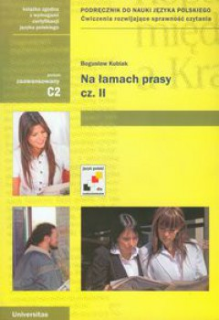

Na łamach prasy, cz.2 written by Bogusław Kubiak The book is a continuation of Kubiak’s Na łamach prasy, cz.1.

The book offers 13 units on various topics to develop:

- speaking (situational dialogues, monologues, discussions, description of images)
- writing (letters, invitations, requests, ads, instructions, notes, short compositions, crossword puzzles)
- reading (proverbs, idiomatic phrases, synonyms, antonyms, official & unofficial language, definitions, humor in Polish)

- Recommended for Advanced Learners & Polish Heritage Speakers.

READING POLISH LITERATURE

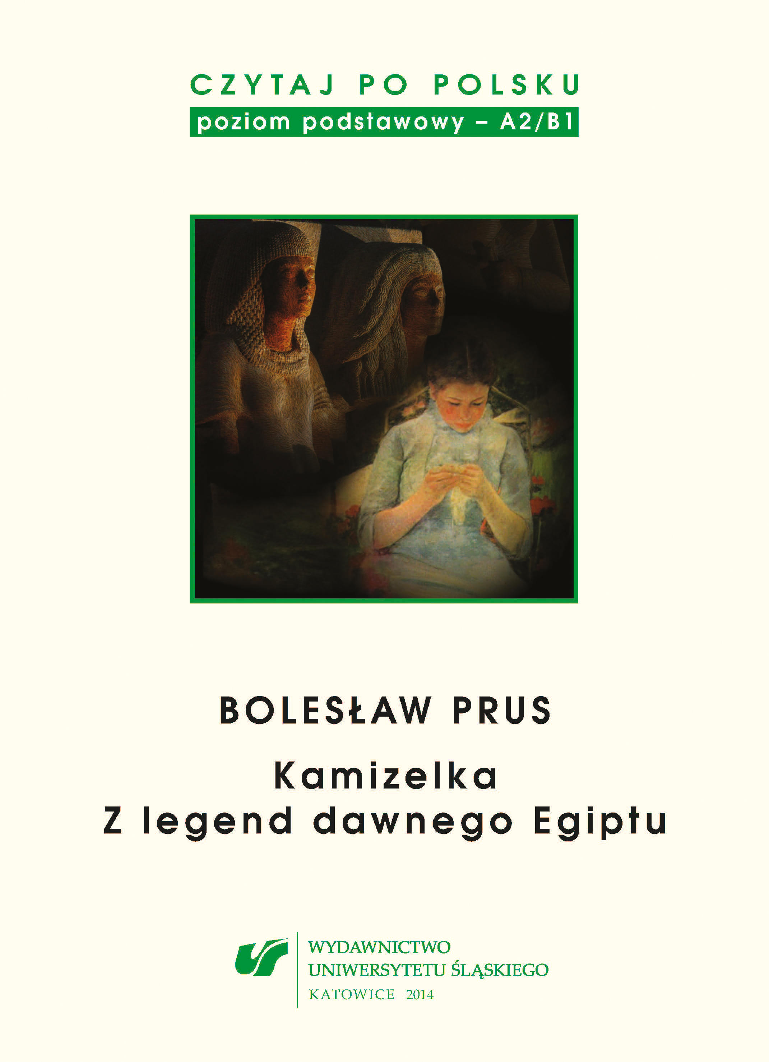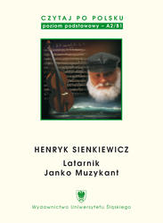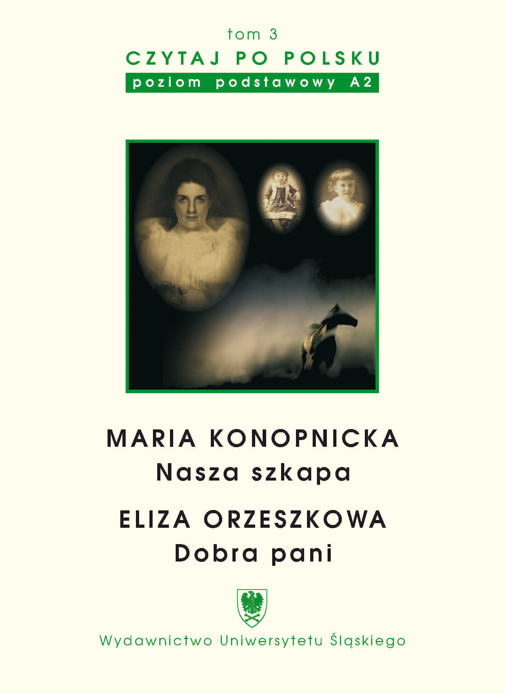
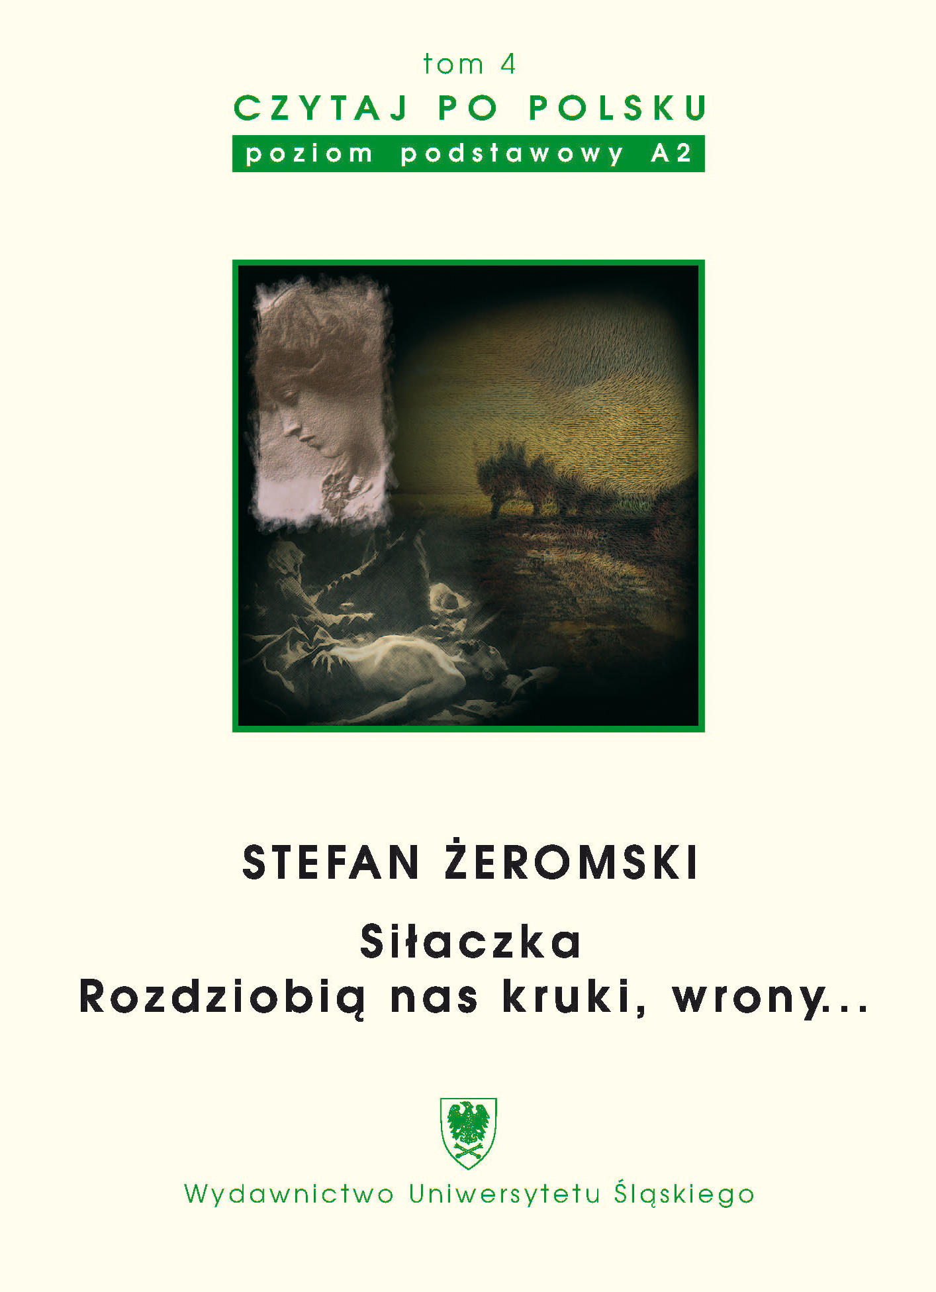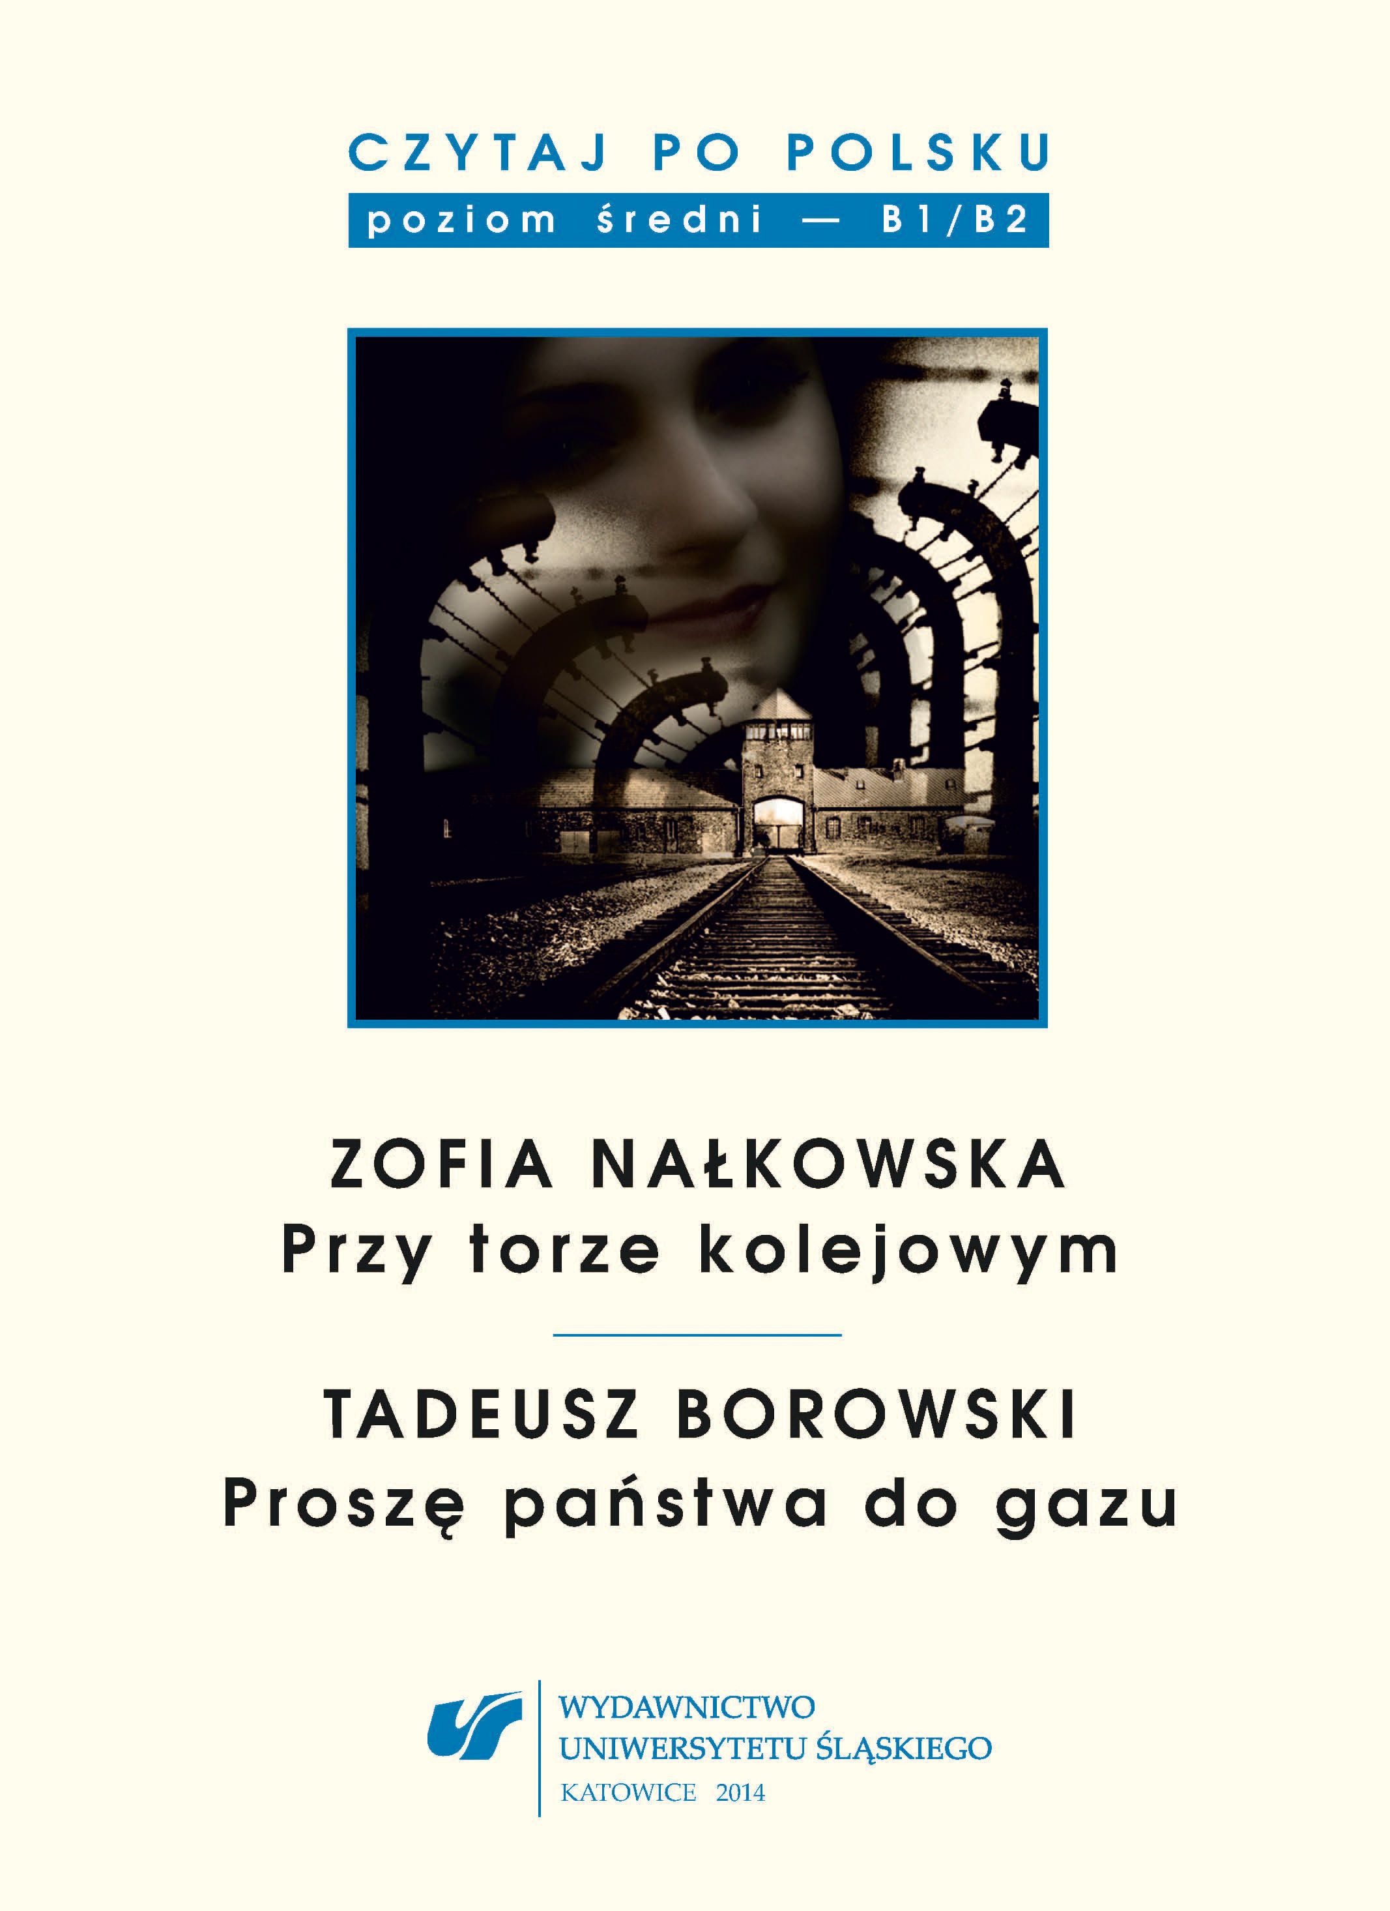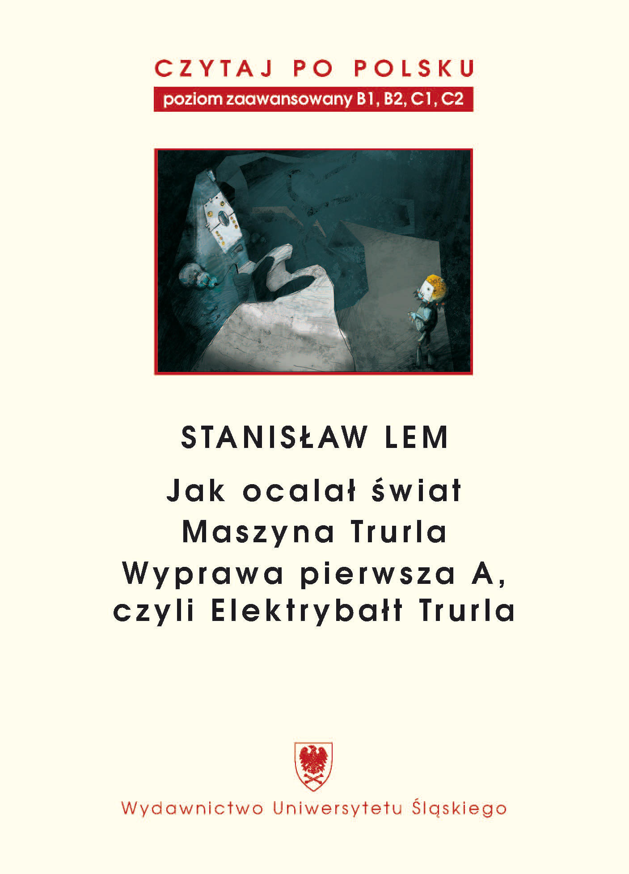

The Series Czytaj po polsku is edited by Romuald Cudak, Wioletta Hajduk-Gawron, Jolanta Tambor, published by Wydawnictwo Uniwersytetu Śląskiego.
Target Skills: reading, vocabulary, writing, speaking, grammar practice
Every volume is an adaptation of a Polish masterpiece written by the major Polish author.

- Recommended for Intermediate, Advanced Learners of Polish Language & Heritage Speakers.

BUSINESS

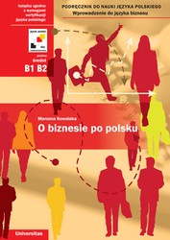

O biznesie po polsku written by Marzena Kowalska introduces to the field of Polish business. The book presents thematic vocabulary, phrases, and articles connected to running a business. The textbook is composed of 15 chapters which also include some chosen topics on grammar.

- Recommended for Advanced Learners & Polish Heritage Speakers.

MEDICINE

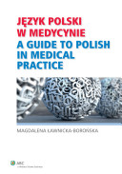

Język polski w medycynie. A Guide to Polish in Medical Practice written by Magdalena Ławnicka-Borońska.

The guide introduces medical terminology in Polish & English.
It has clear charts and drawings of human anatomy.
The vocabulary and phrases include the anatomy of particular systems, diseases, and their manifestations, taking history (dialogues), examining and diagnosing, as well as disease and case presentations.
The book contains vocabulary useful in hospitals and pharmacies.

- Recommended for students in pre-medicine curriculum and medical/health majors and minors.

SPEAKING

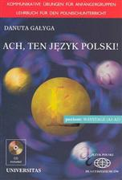

Ach, ten język polski! + CD written by Danuta Gałyga offers communicative activities in Polish for Beginners.

The textbook is composed of 10 units on such topics as:

Greetings & farewell expressions
Introducing oneself & others
Attracting attention
Expressing joy & grief
Offering & inviting
Eating & drinking
Expressing satisfaction
Health & personal hygiene
Giving advice
Everyday life
Work
Expressing opinions

- Recommended for Elementary Level

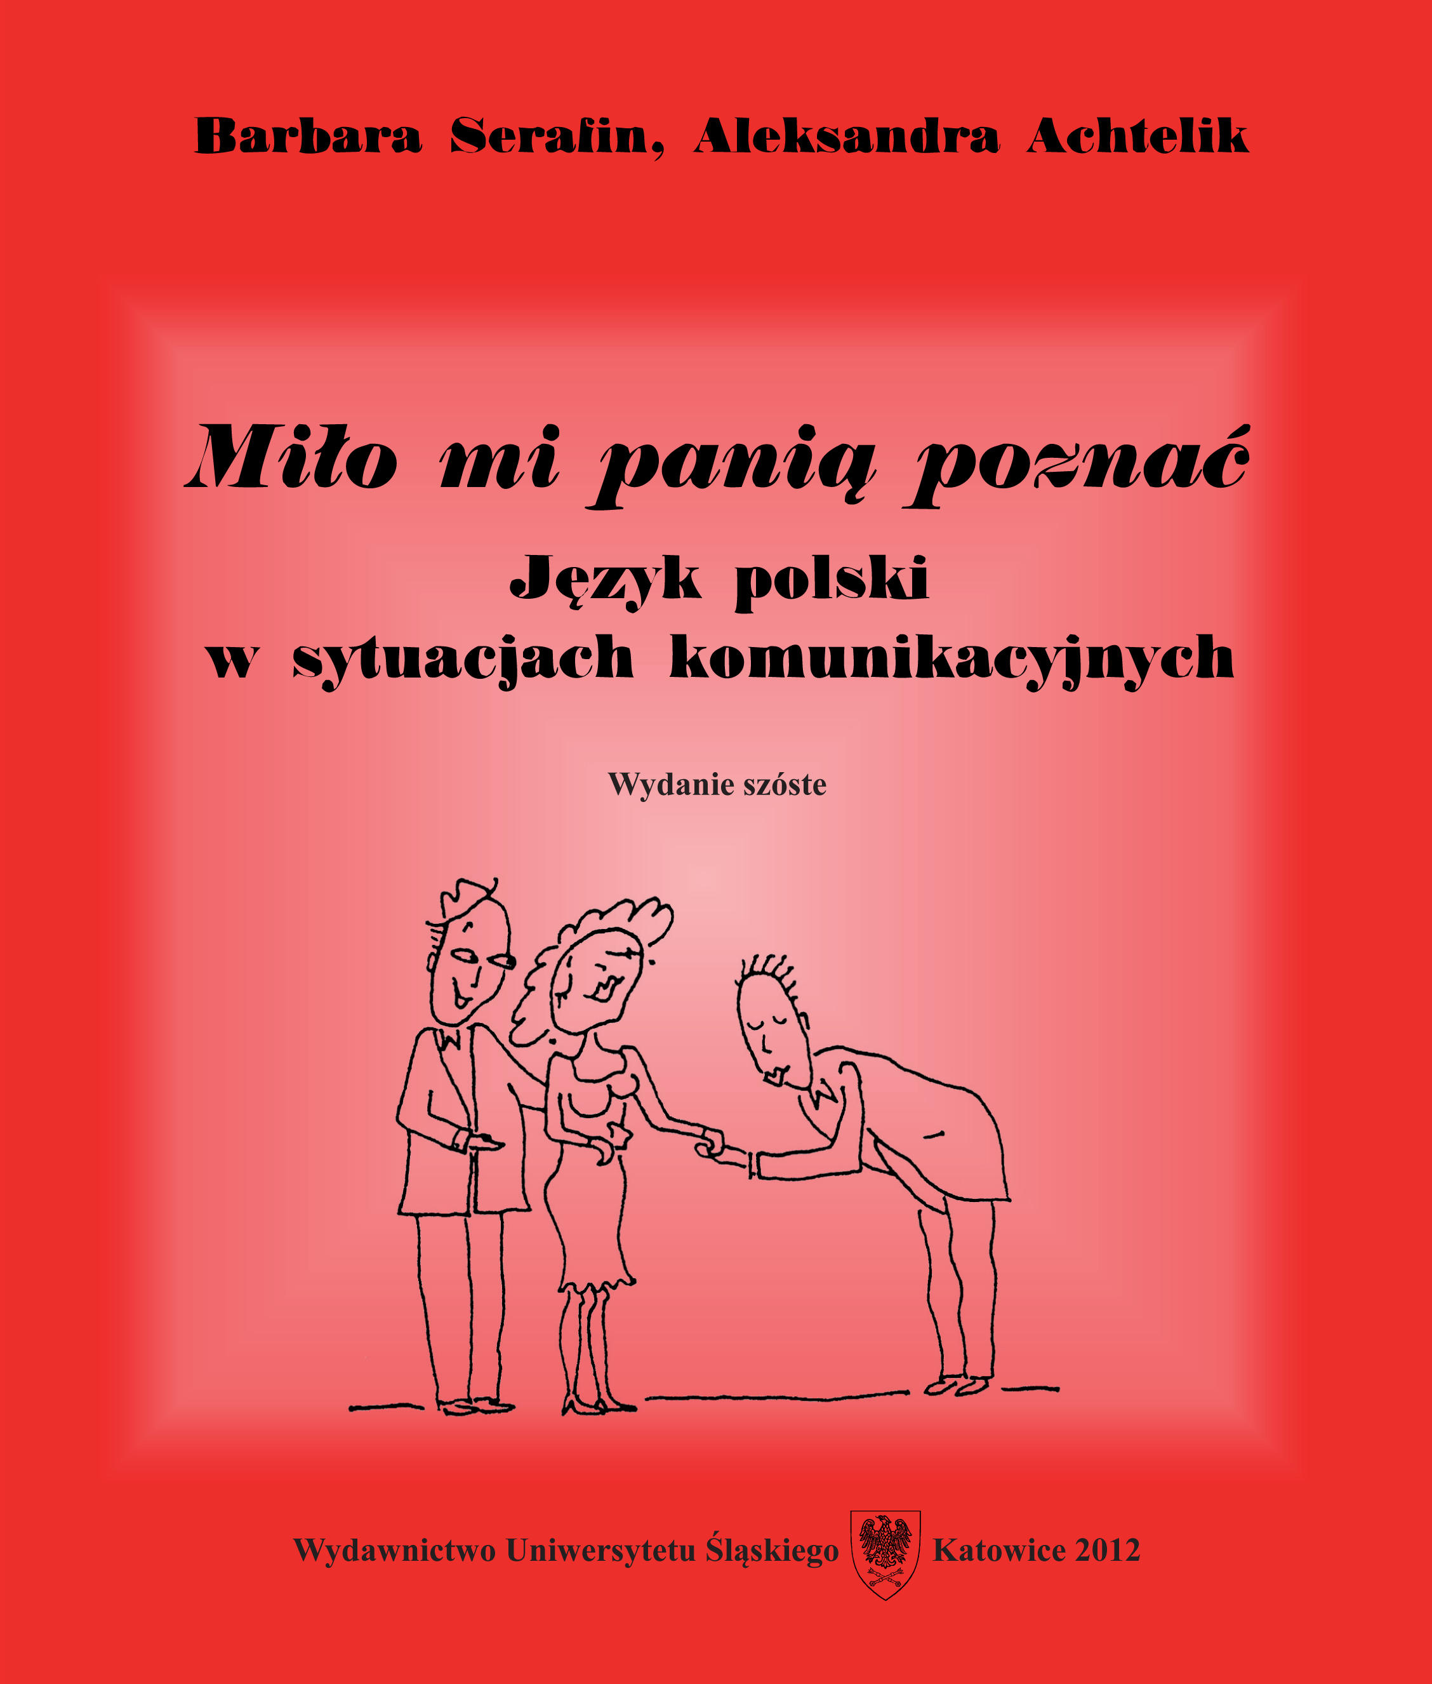

Miło mi panią poznać. Język polski w sytuacjach komunikacyjnych + CD written by Barbara Serafin & Aleksandra Achtelik, published by Wydawnictwo Uniwersytetu Śląskiego, is composed of:

1. Communication
Greetings & farewell expressions
Introducing oneself & others
At a newspaper stand
Expressing time
Ordering a taxi
At a post office
Asking for road directions
Making a phone call
Grocery shopping
At a restaurant
Weather and Calendar
At a train & bus station
Visit at a doctor’s office
Clothes
At a hotel
2. Charts on Grammar
3. Translation of dialogues into the English, German, French, Spanish, and Russian

- Recommended for Beginning Level
SINGING

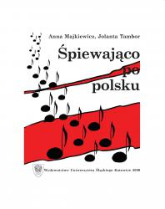

Book + CD by Anna Majkiewicz & Jolanta Tambor.
The book is composed of 6 units with songs on such topics as:

Polish alphabet
Instrumental
Locative
Accusative
Verb + Genitive
Present & past tenses
Conditional mood
Participles
Numerals
Months
Days of the week

  - Recommended for Elementary & Intermediate Levels

DICTIONARY

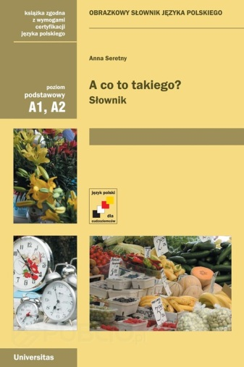

A co to takiego? Słownik by Anna Seretny, published by Universitas is addressed to beginners & those who want to broaden their knowledge of Polish vocabulary.
All entries of the dictionary are defined by pictures.
The lexical material is presented in 32 subject areas.

- Recommended for Elementary and Intermediate Polish classes.

Kościuszko Foundation Dictionary

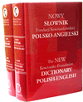

Kościuszko Foundation Dictionary English-Polish, Polish-English with CD-ROM, contains over 140,000 entries with 400,000 meanings and 100,000 idioms, including British.

Dictionary features
- technical and specialized vocabulary in such areas as law, economics, computers, the military and medicine, mass media, sports, and sciences
- literary and colloquial expressions, slang, archaic usage words in context, illustrated by original sentences

CD-ROM contains
- all entries from both volumes
- grammatical information and phonetic transcription
- allows user search words, copy directly into documents, personalize by adding and deleting entries
- and many other features

- Recommended for all the levels of Polish language.

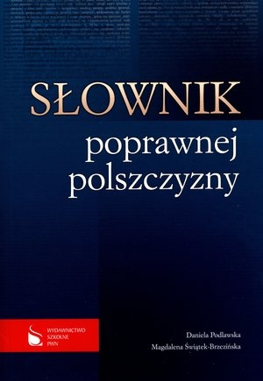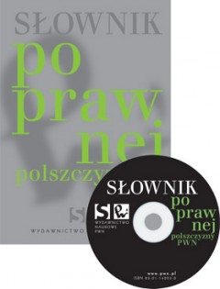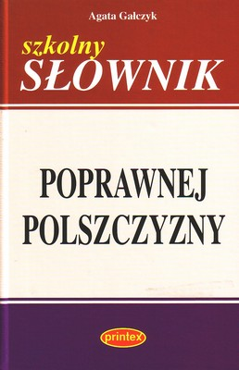

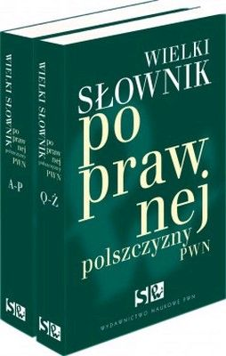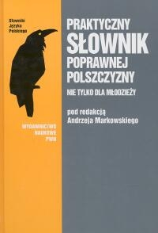

- Recommended for Native & Heritage Speakers of Polish language.

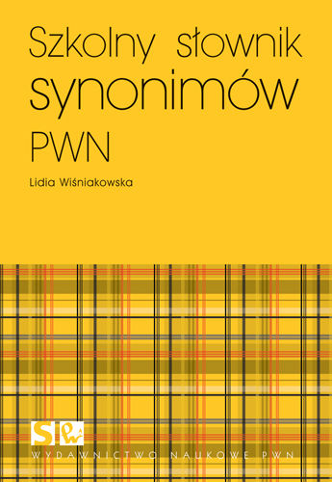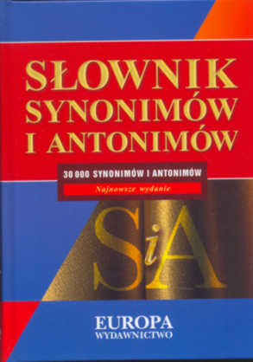

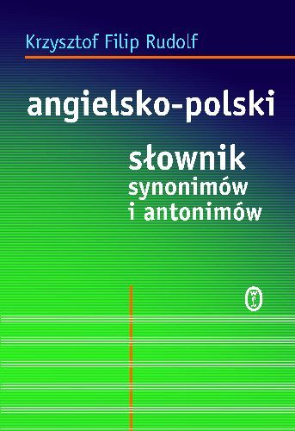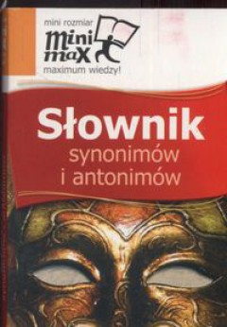
- Recommended for Native & Heritage Speakers of Polish language.

WEBSITES with POLISH TEXTBOOKS

http://www.universitas.com.pl/katalog/kat_38
http://prologpublishing.com/pliki/katalog_2014.pdf

